GreatAdventures.ca: An Online Activity Booking Service

Centennial college | SETAS

SOFTWARE ENGINEERING METHODOLOGIES - COMP 225

Mary Romeral 300999302 Section 003

Kelly Tan 300991647 SECTION 002

DANYANG DUAN 300998499 Section 001

Harsimran Kaur 300988092 Section 001

2018

Contents

System Vision Document 2

Interviews 3

Workflow Diagram: Registration Subsystem 6

Workflow Text: Registration Subsystem 7

Workflow Diagram: Booking Subsystem 8

Workflow Text: Booking Subsystem 9

Workflow Diagram: Payment Subsystem 10

Workflow Text: Payment Subsystem 11

UML Use Case Diagram: Registration Subsystem 12

UML Use Case Diagram: Booking Subsystem 13

UML Use Case Diagram: Payment Subsystem 14

List of Use Cases 15

User Stories and Use Case Full Descriptions 17

Domain Class Diagram 20

Entity Relationship Diagram 21

System Sequence Diagrams 22

State Machine Diagrams 23

Gantt Chart 24

Appendix 1: Stakeholder Register 25

Appendix 2: Minutes of Team Meetings 25

Appendix 3: Minutes of Meetings with Customers 28

# System Vision Document

**Problem Description:**

There are many activities or classes available to school-aged children, but the fact that there is no centralized system for children and parents to view and register for these programs makes it difficult to choose the right activity. Parents end up having to check different sources on the web or in person, ultimately wasting time and resources, and often not being able to really see all their options before making a final decision. Moreover, instructors/program facilitators also have a limited market unless they pay for expensive advertising.

Because of this, there is a need for a website that will address the issues and make activity selection easier for families.

**System Capabilities:**

The users (families) will register on the website to access the features.

The website will include a database of activities/courses available in the Greater Toronto Area.

The website will allow users to filter by activity type, age, and location, allowing better customization and matching of an appropriate program depending on the child’s needs and interests.

The users have the capability to choose which family member will register for certain programs.

Registration to activities and booking can be done as soon as they have access to the internet.

The website will allow providers (instructors/program facilitators/partner organizations including camps and recreation centres) to reach out to a larger market if they register with our service.

There will a dedicated area for the providers to manage course/student information.

The service will allow providers to check on the number of their potential/final enrollees, as well as view information about them.

The providers will share their information/updates with the service so that we can pull information from them and provide them to the users.

Business Benefits:

The website will make activity searching, registration, and booking easily accessible.

The service will allow users to save on resources. It is paperless and eliminates the need to make appointments and go to different locations, allowing users to save time and money.

The service will allow providers to save money. Advertising through the service is cheaper than print media, radio, and television.

The website builds a better relationship between providers and users.

Users can input their personal information once and register for multiple courses from multiple locations without repeating the process multiple times.

This system allows users to comment about and rate their experience in the courses.

# Interviews

|  |  |  |
| --- | --- | --- |
| **ANALYST**  **Interview Questions** | | |
| Question | Stakeholder | Answer |
| With currently available activity registration and booking services in mind, what would you say is the best feature? | User | My city's local recreation centre allows me to filter activities by age and choose which family member will register for a certain activity. |
| With the same services in mind, what feature would you say is lacking? | User | It would be nice to have a more user-friendly interface. I have to click through a lot of links on their website before I am able to view the activities my family has signed up for. |
| If you register for an online activity registration and booking service, how likely are you to use it as your primary search tool for locating activities your family is interested in versus a regular search engine? | User | If it is able to give me a comprehensive list of activities in my area, I will be very likely to just go straight to that service instead of going through Google or any other search engine first. |
| How does your organization currently accept registrations and course bookings? | Provider | We encourage people to come to our physical location to check out the facility and then register on site if they are interested. We also have a form they can fill out for inquiries online. |
| What are your thoughts on an online registration and booking service that allow providers like yourself to get more members? | Provider | We would definitely be interested in registering with an online booking service to help our potential customers who do not have the time to come to the facility in person. It will also be helpful for those who come in person but are not able to make a decision on the same day. |
| Apart from partnering with us, would you be willing to pay a fee in order to advertise with us? Your advertisements will appear as banners on our website, and a link to your website will show as top links with the word “Ad” next to them when users search for activities in your category. | Provider | Yes. We want to make sure we use all available avenues for advertising in order to get more prospective members. As long as the price is reasonable, we will be okay with paying to advertise with you. |
| We will be offering our new users 10 percent off on us for their first activity after registration. What other perks or incentives, if any, will you as a provider be able to offer our users? | Provider | We can offer exclusive promotions and discounts especially during off-peak seasons so that we can encourage more users to book our activities through your service. |
| How can we ensure that we can protect our users' data from theft? | Web Development and Security Team Lead | We will require strong passwords upon registration and this, along with other personal information, will be encrypted. We will also lock the users' account after four consecutive attempts to sign in with an incorrect password. In order to unlock, they have to call us or wait three hours. |
| What can the team do in order to maintain a smooth running website that performs well? | Web Development and Security Team Lead | We can extend the same cancelation and refund policy that we already have in place to members of the service. |
| How will the marketing team ensure that we are getting in touch with and partnering with all the best providers in the Greater Toronto Area? | Marketing Executive | Our team will generate leads using multiple platforms including social media, online correspondence, and joining conventions for big and small businesses. We will work constantly to make sure we that our leads become our partners. |

# Workflow Diagram: Registration Subsystem

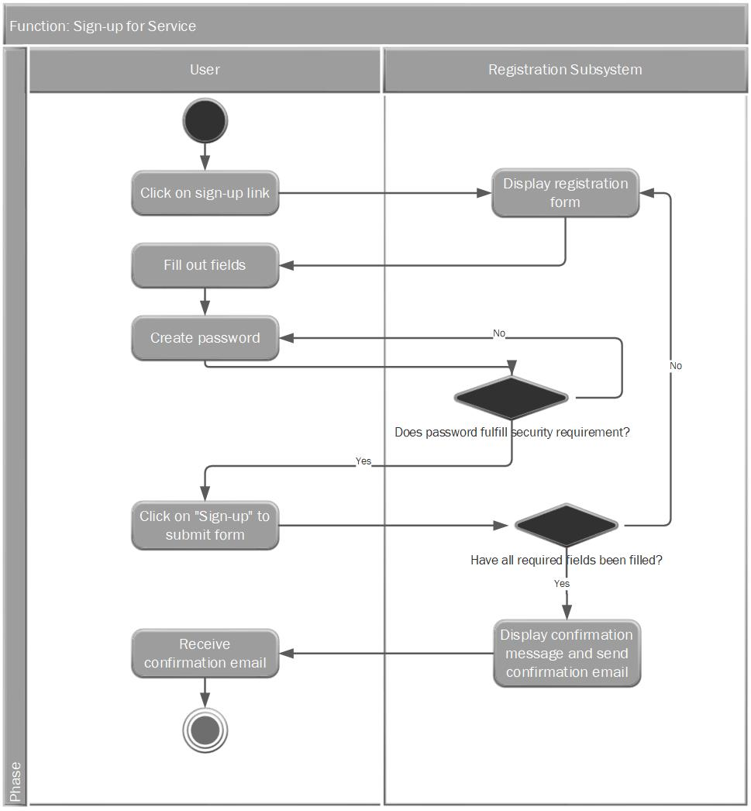

# Workflow Text: Registration Subsystem

**Function: Sign-up for Service**

1. User: Click on the sign-up link.
2. Registration subsystem: Display registration form.
3. User: Fill out required fields.
4. User: Choose a password that fulfills the security requirement.
5. Registration subsystem: Confirm password strength.
6. If password does not fulfill the security requirement, display error message.
7. If password fulfills the security requirement, display a check mark next to the password field and allow customer to submit the form when ready.
8. User: Click on the “Sign up” button.
9. Registration subsystem: Verify that all required information has been filled out by the customer.
10. Registration subsystem: If fields are incomplete, display the registration form again.
11. Registration subsystem: If fields are complete, display a confirmation message and send a confirmation email.
12. User: Receive confirmation email.
13. End

# Workflow Diagram: Booking Subsystem

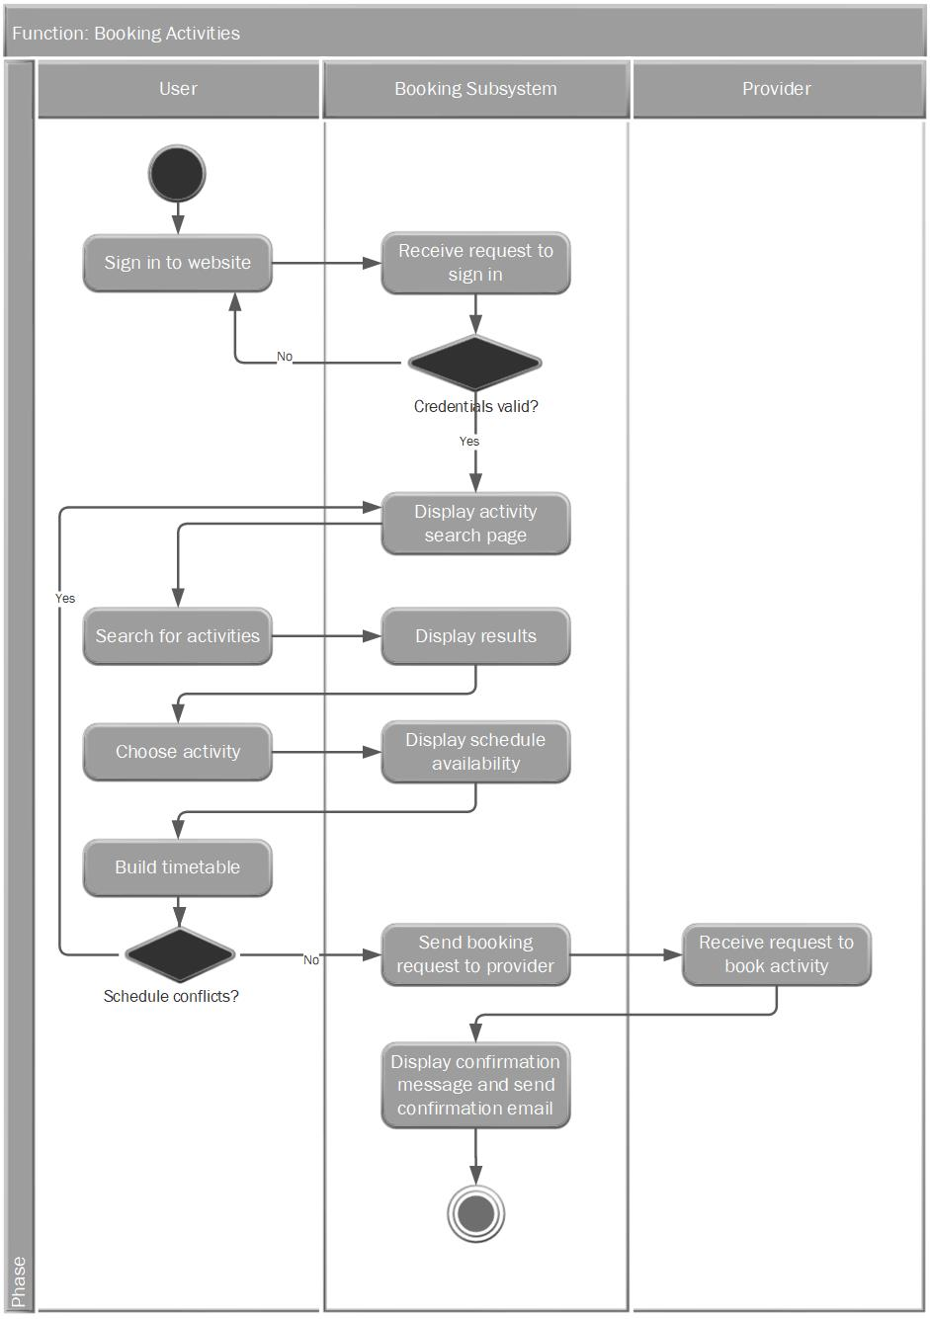

# Workflow Text: Booking Subsystem

**Function: Book Activities**

1. User: Sign in to the website.
2. Booking subsystem: System: Receive request to sign in.
3. Booking subsystem: Check if credentials are valid.
4. Booking subsystem: If credentials are not found, go back to the sign in page.
5. Booking subsystem: If credentials are valid, continue to activity search page.
6. User: Search for activities.
7. Booking subsystem: Display results.
8. User: Choose activity.
9. Booking subsystem: Display possible schedules.
10. User: Build timetable.
11. If there are schedule conflicts, go back to choose activity page.
12. If there are no conflicts, send request to provider to book activity.
13. Provider: Receive request to book activity.
14. Booking subsystem: Display a message advising the user to wait 24 to 48 hours for a booking confirmation and payment request.
15. End

# Workflow Diagram: Payment Subsystem

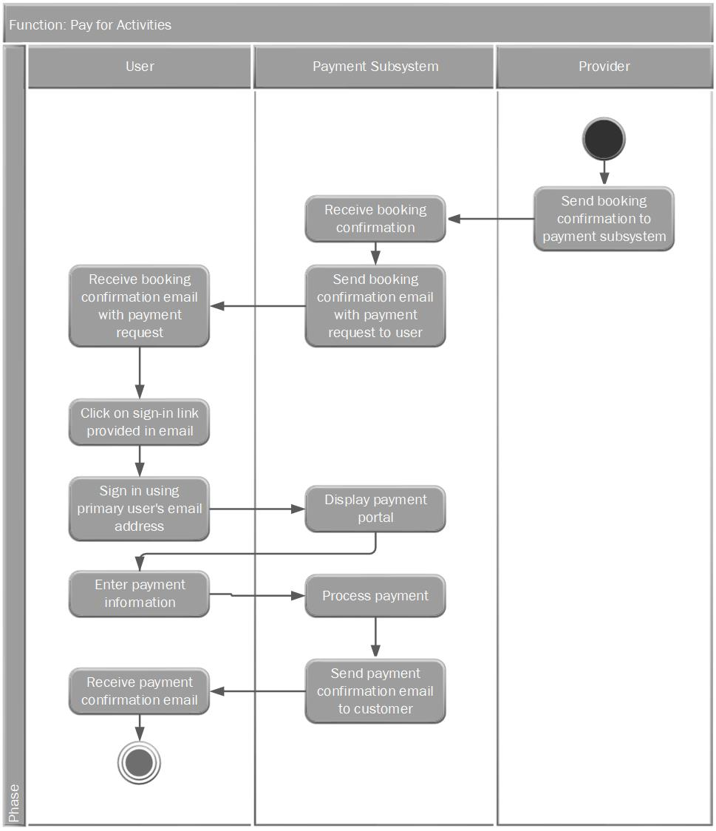

# Workflow Text: Payment Subsystem

**Function: Pay for Activity**

1. Provider: Confirm booking with the payment subsystem.
2. Payment subsystem: Receive booking confirmation from provider.
3. Payment subsystem: Send booking confirmation email with payment request to customer.
4. User: Receive booking confirmation email with payment request.
5. User: Click on the link to sign in to the primary user’s account from the email.
6. User: Sign in to the primary user’s account with their email address.
7. Payment subsystem: Display payment portal.
8. User: Enter payment information.
9. Payment subsystem: Communicate with third party payment processor.
10. Payment processor: Communicate with provider.
11. Payment processor: Send payment confirmation to the payment subsystem.
12. Payment subsystem: Receive payment confirmation.
13. Payment subsystem: Send payment confirmation email to the user.
14. User: Receive payment confirmation email.
15. End

# UML Use Case Diagram: Registration Subsystem

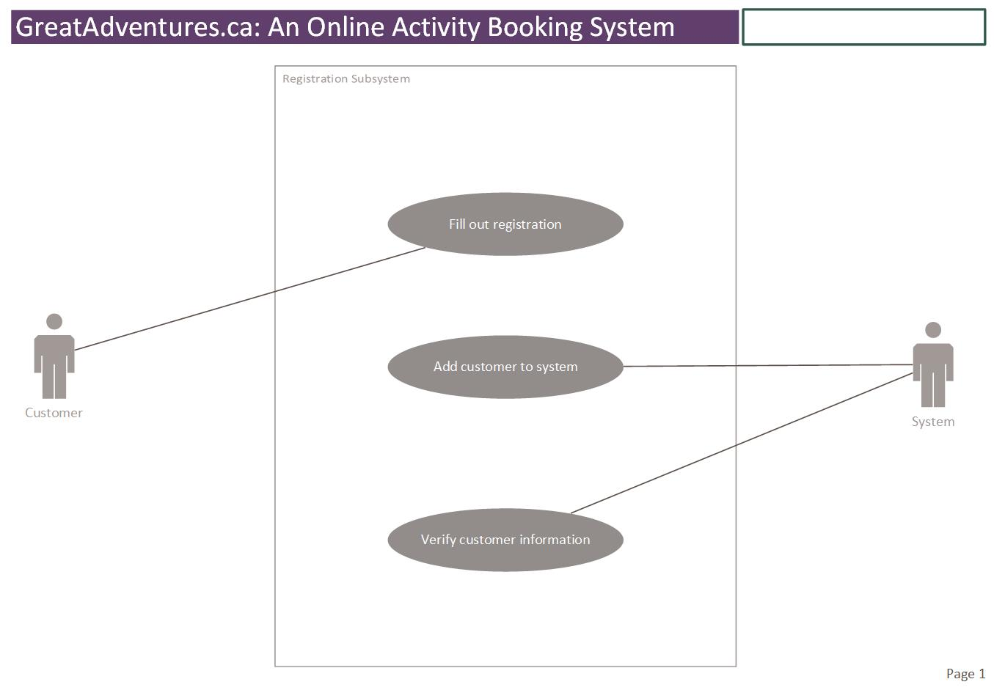

# 

# UML Use Case Diagram: Booking Subsystem

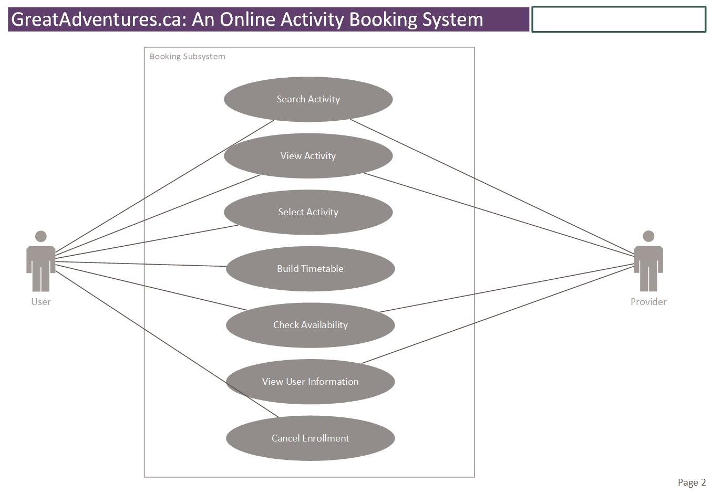

# UML Use Case Diagram: Payment Subsystem

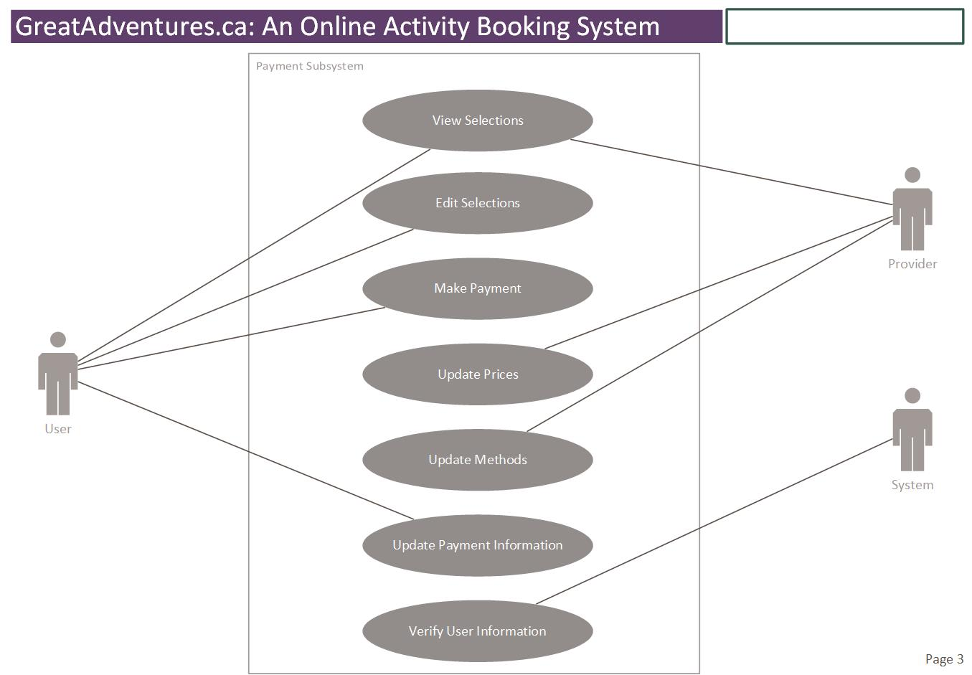

# Prioritized List of Use Cases

Diagram #1: Registration Subsystem

|  |  |  |  |  |
| --- | --- | --- | --- | --- |
| **#** | **Goal use case name** | **Actor(s)** | **Brief description** | **Priority(H,M,L)** |
| 1 | Fill out registration | User | User registers for the service. | H |
| 2 | Add customer to system | System | System stores customer information. | H |
| 3 | Verify customer information | System | System verifies user information after user fills in the registration form. | H |

Diagram #2: Booking Subsystem

|  |  |  |  |  |
| --- | --- | --- | --- | --- |
| **#** | **Goal use case name** | **Actor(s)** | **Brief description** | **Priority(H,M,L)** |
| 1 | Search activity | User/ Provider | User and provider can search for activities after logging in. | H |
| 2 | View activity | User/Provider | User and provider can view activity information. | H |
| 3 | Select activity | User | User is able to choose the activities they are interested in. | H |
| 4 | Build timetable | User | User chooses the time and date (schedule) for the activity. | H |
| 5 | Check availability | User/Provider | User and provider check timetable for availability. | H |
| 6 | Cancel enrollment | User | User is able to cancel the booking/enrollment of activities. | M |
| 7 | View user information | Provider | Providers can view enrollee information. | H |

Diagram #3: Payment Subsystem

|  |  |  |  |  |
| --- | --- | --- | --- | --- |
| **#** | **Goal use case name** | **Actor(s)** | **Brief Description** | **Priority(H,M,L)** |
| 1 | View selections | User/Provider | After user has chosen their preferred activities, the provider and the user are able to view the selected activities. | M |
| 2 | Edit selections | User | The user can edit the timetable for their selected activities or remove the activities. | M |
| 3 | Update prices | Provider | Providers are able to change the activities’ prices. They can lower the price or make it higher. | H |
| 4 | Update methods | Provider | Provider decides on what types/methods of payments they accept. | H |
| 5 | Update payment information | User | Customer fills out his/her payment information. | H |
| 6 | Verify user information | System | Administrator verifies customer information to process the payment. | H |
| 7 | Make payment | User | The user fills out the payment form each time they book an activity. | H |

# User Stories and Use Case Full Descriptions

**User Story**

As a primary user, I want to easily register for the service so that I can be more efficient in my search for activities.

**Acceptance Criteria**

1. It must be easy to navigate from any part of the website to registration.

2. The registration form will ask for the most important details needed for creating an account.

3. A confirmation message will be displayed upon successful registration.

4. A confirmation email will be sent to a valid email address.

|  |  |  |
| --- | --- | --- |
| Use case name: | Fill out registration | |
| Scenario: | Fill out the online registration form to create an account | |
| Triggering event: | New customer wants to register for the service | |
| Brief description: | User signs up for the service by entering basic information into the registration form | |
| Actors: | Primary user | |
| Related use cases: | Might be invoked by *Select activity* use case | |
| Stakeholders: | User, Web Development Team Lead | |
| Preconditions: | User must navigate to registration link  Registration Subsystem must be available | |
| Post conditions: | Registration account must be created and saved  One email address must be used and saved  One address must be used and saved  Email, address and account must be associated with user | |
| Flow of activities: | Actor | System |
|  | 1. User indicates desire to create customer account. 2. User enters some basic information to create an account. 3. User clicks on the button to register. | * 1. System prepares to add new user account.   2. System displays registration form.   3. System validates information entered by user.   2.2 System verifies email address.   * 1. System associates user with email address.   2. System returns confirmation message and sends email. |
| Exception conditions: | * 1. Basic customer data is incomplete.   2. Basic customer data is in incorrect format.   2.1 The email address is not valid. | |

**User Story**

As a user (primary user or family member), I want to add a schedule for an activity of my liking so that I can keep an organized timetable without conflicts.

**Acceptance Criteria**

1. All current schedules for existing enrollments will be displayed.

2. The system must provide all available options for the selected activity.

3. The system must display a message when there are conflicting schedules for selected time and dates.

4. The user must be able to confirm changes to be made before finalizing the timetable.

5. A confirmation of changes will be displayed.

|  |  |  |
| --- | --- | --- |
| Use case name: | Build timetable | |
| Scenario: | Build an online timetable to easily view schedules for all activities | |
| Triggering event: | User wants to choose schedules for activities that they want to book, or add schedules for new activities if they have existing enrollments | |
| Brief description: | User chooses the time and dates for selected activity or activities | |
| Actors: | Primary user, family member | |
| Related use cases: | Might be invoked by *Select activity* use case | |
| Stakeholders: | User, Web Development Team Lead, Provider | |
| Preconditions: | User must be logged in to the account  Booking Subsystem must be available | |
| Post conditions: | A schedule must be created and saved to the timetable  The timetable must be available for viewing  The timetable must be editable | |
| Flow of activities: | Actor | System |
|  | 1. User chooses to add activity to timetable 2. User chooses desired time and dates 3. User accepts changes to timetable | * 1. System receives user’s request   2. System displays availability   3. System confirms availability   4. System displays draft of schedule   5. System accepts confirmation   3.2 System shows new timetable |
| Exception conditions: | * 1. User fails to log in to the system.   2.1 The time chosen is in conflict with existing schedules.  2.2 The dates chosen are in conflict with existing schedules. | |

**User Story**

As a user (primary user of family member), I want to be able to cancel my enrollment to activities from the same website so that I can complete all my activity related tasks efficiently from one place.

**Acceptance Criteria**

1. All current schedules for existing enrollments will be displayed.

2. A button for cancelling an enrollment will be available for all activities.

3. A message must be displayed if the provider has special conditions for cancelling an enrollment (e.g. Activity cannot be cancelled when it is current and/or user has to call provider directly).

|  |  |  |
| --- | --- | --- |
| Use case name: | Cancel enrollment | |
| Scenario: | Cancel an activity that has previously been booked online | |
| Triggering event: | User wants to cancel their enrollment to an activity | |
| Brief description | User chooses to cancel their enrollment to an activity that has previously been booked | |
| Actors: | Primary user, family member | |
| Related use cases: |  | |
| Stakeholders: | User, Web Development Team Lead, Provider | |
| Preconditions: | User must be log in to the account  At least one activity should be selected | |
| Post conditions: | The timetable is updated to reflect changes | |
| Flow of activities: | Actor | System |
|  | 1. User views existing enrollment or timetable 2. User chooses activity 3. User chooses *Cancel Enrollment* button 4. User confirms cancellation | * 1. System displays enrollments or full timetable   2. System displays options for activity   3. System prompts user to confirm cancellation   4.1 System displays confirmation of cancellation  4.2 System send email to confirm cancellation |
| Exception conditions: | * 1. User chooses an activity that is current and cannot be cancelled at provider’s request.   2. User chooses an activity that cannot be cancelled at provider’s request. | |

# Domain Class Diagram

Description:

The system’s **User** can be a Primary User, Family Member, or Provider. *However, when referring to Primary User/Family Member vs. Provider, we just use User vs. Provider.*  
**PaymentInfo** cannot exist without a **Primary User**.  
An **Activity** cannot exist without a **Provider**.  
Each **FamilyMember** can have 0 or many enrollments (**Enrollment** class).  
There can be 1 and only 1 **Timetable** associated with 1 and only 1 **FamilyMember**.  
Each Provider can have o or many activities (**Activity** class).

# Entity Relationship Diagram

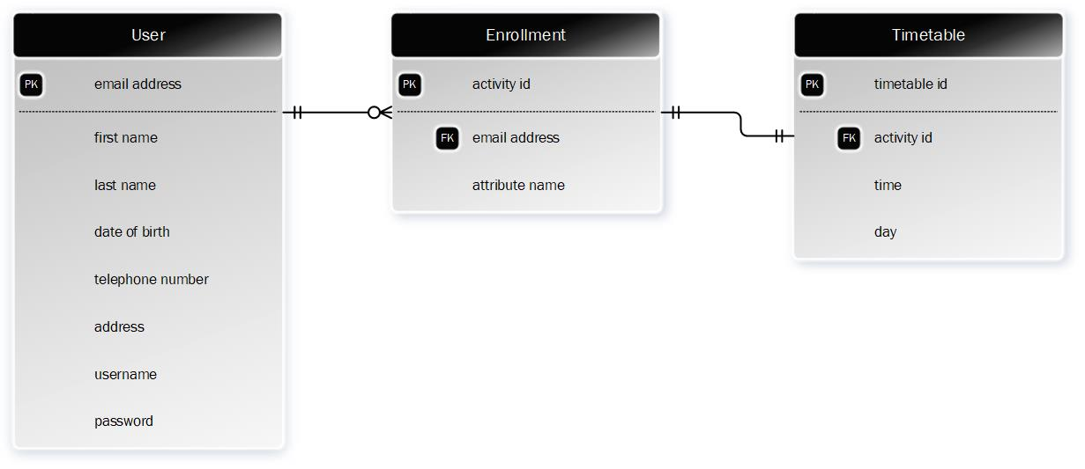

Description:

Above is an Entity Relationship Diagram sketch based on the GreatAdventures.ca system and how a user can easily keep track of their enrollments and timetables once they have registered for the service and booked their activities.

1 and only 1 **User** can have 0 or more **Enrollments**, where an enrollment is an activity that has been booked and confirmed.  
1 and only 1 **Enrollment** can be associated with one and only **Timetable**.

System Sequence Diagrams

Figure A (top): System Sequence Diagram showing Registration system sequence

Figure B (bottom): System Sequence Diagram showing Booking system sequence

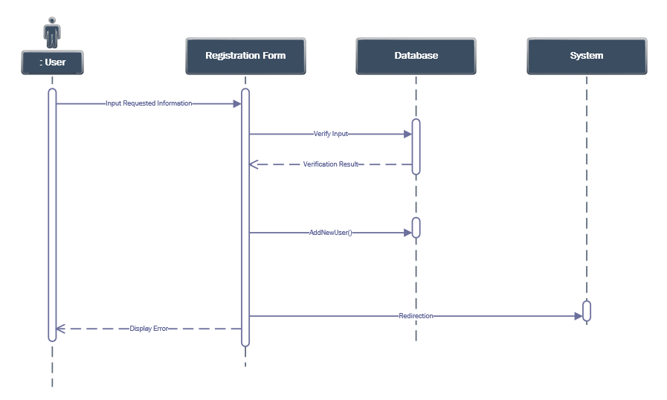

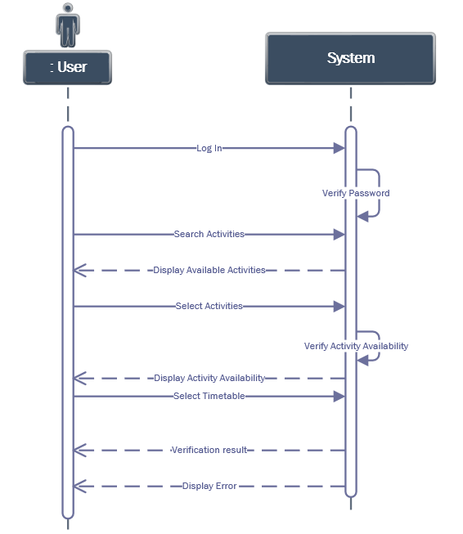

# State Machine Diagrams

Figure A (top): Signing In

Figure B (bottom): Searching Activities/Creating Timetables

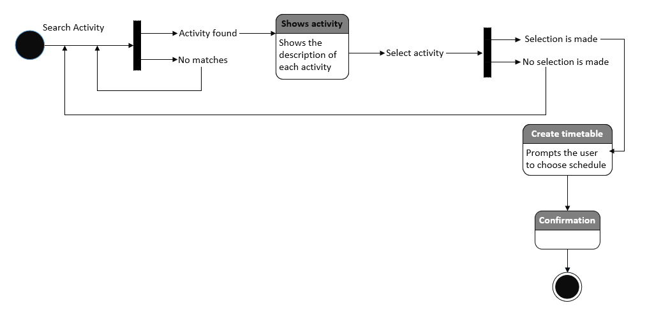

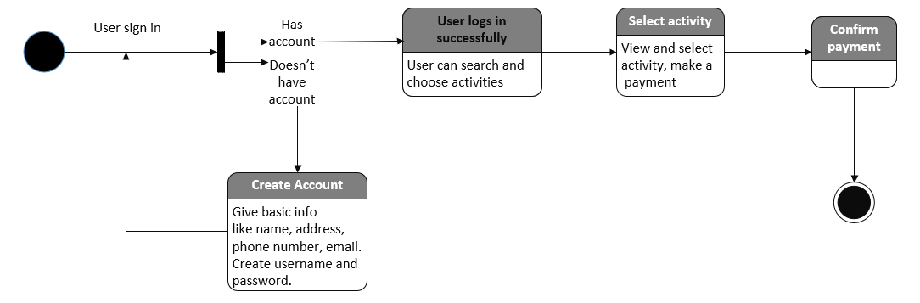

# Gantt Chart



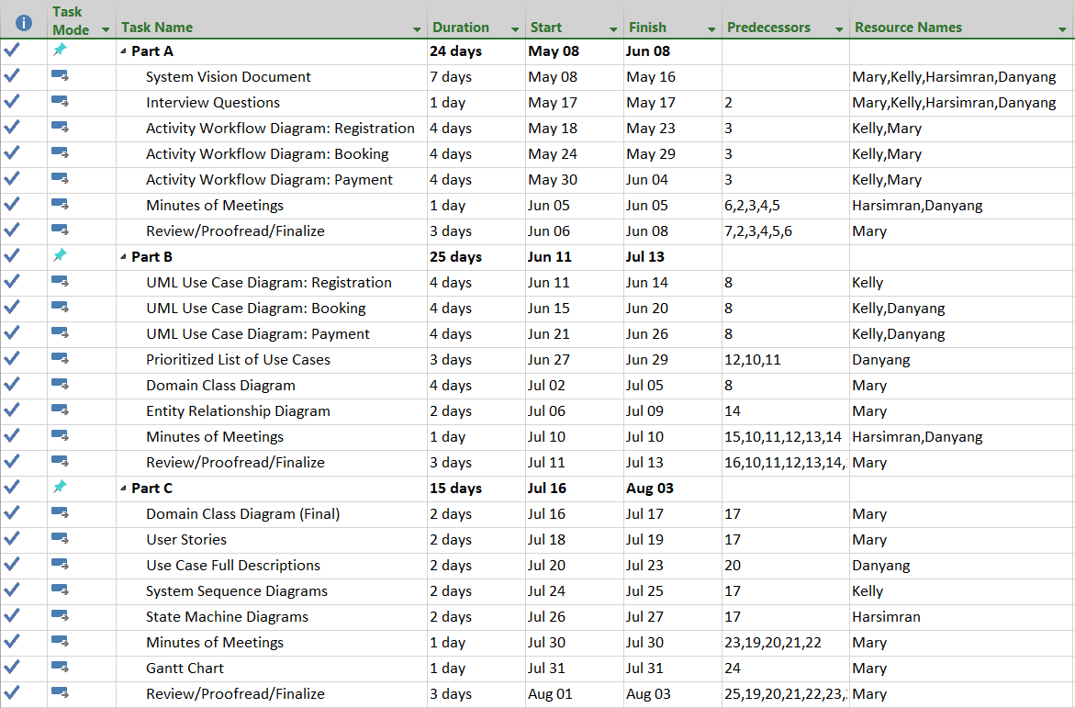

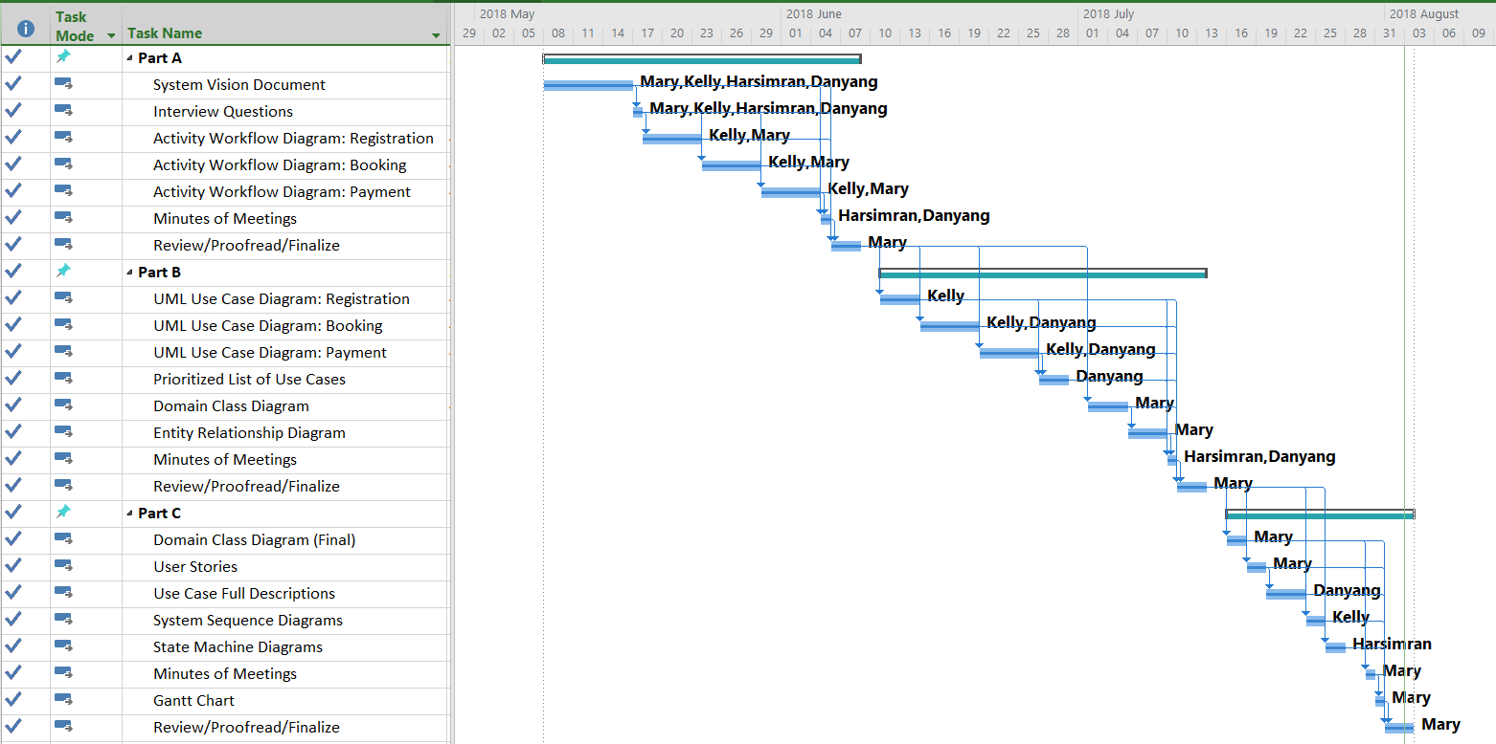

**Please click on the following icon to access the Gantt Chart:**



# Appendix 1: Stakeholder Register

|  |  |  |  |  |  |
| --- | --- | --- | --- | --- | --- |
| Stakeholder Register | | | | | |
| Stakeholder Name | Stakeholder  Position | External/Internal | Stakeholder contact details | Operational/ Executive | Interest  (high, medium, low) |
| Ann Lee | User | External | 4162503355 | Operational | High |
| Lily Duan | Provider/Supplier | External | 6473302740 | Operational | High |
| Anne Smith | Web Development Team Lead | Internal | 4162279547 | Executive | High |
| John Drake | Marketing Executive | Internal | 3695857845 | Executive | High |

# Appendix 2: Minutes of Team Meetings

|  |  |  |  |  |  |
| --- | --- | --- | --- | --- | --- |
| **Minutes of meetings log between team members** | | | | | |
| **Meeting #** | **Date**  dd/mm/yyyy | **Duration**  minutes | **Names of attendees** | **Type**  (in person, over the phone, over the internet) | **Key actions agreed upon** |
| **1** | 08/05/2018 | 50 | Harsimran Kaur | In person | * Topic of the project: Activity Search and Selection, Online Registration and Booking * Problem: The lack of a centralized system for searching for activities from multiple providers and registering/booking on the same platform * System capabilities: Registration to service is required; activities can be filtered by age, activity type, location. * Business benefits: accessibility, time saving, affordable |
| Danyang Duan | In person |
| Kelly Tan | In person |
| Mary Romeral | In person |
| **2** | 15/05/2018 | 60 | Harsimran Kaur | Over the internet | * Agreed on and finalized other features available to our users: commenting and rating on activities and providers’ services, advertising possibilities, family member selection and activity matching |
| Danyang Duan | Over the internet |
| Kelly Tan | Over the internet |
| Mary Romeral | Over the internet |
| **3** | 22/05/2018 | 90 | Harsimran Kaur | In person | * Made a draft of the activity booking workflow (diagram and textual) |
| Danyang Duan | In person |
| Kelly Tan | In person |
| Mary Romeral | In person |
| **4** | 29/05/2018 | 90 | Harsimran Kaur | In person | * Completed the service registration workflow (diagram and textual) * Agreement on registration and sign in process: The primary user’s email address and password will be used to sign in to the account as the primary user with full privileges and access to all features. The primary user can also sign in using a unique username that they can choose when they first register for our services, plus their password. Any other member will use an individual unique username and password, which they can choose at the time that they are added as a family member. The primary user will have access to everyone’s information when they sign in using their email address. |
| Danyang Duan | In person |
| Kelly Tan | In person |
| Mary Romeral | In person |
| **5** | 05/06/2018 | 90 | 1. Harsimran Kaur | In person | * Made changes to the activity booking workflow (diagram and textual). Completed the payment workflow (diagram and textual). |
|  |  |  | 2. Danyang Duan | In person |
|  |  |  | 3. Kelly Tan | In person |
|  |  |  | 4. Mary Romeral | In person |

|  |  |  |  |  |  |
| --- | --- | --- | --- | --- | --- |
| **Minutes of meetings log between team members** | | | | | |
| **Meeting #** | **Date**  dd/mm/yyyy | **Duration**  minutes | **Names of attendees** | **Type**  (in person, over the phone, over the internet) | **Key actions agreed upon** |
| **1** | 12/06/2018 | 90 | 1. Harsimran Kaur | In person | * Discussed and agreed on use case names, actors and brief descriptions of the registration subsystem use case diagram * Discussed the priority of each use case * Drew the use case diagram of registration subsystem using Visio |
| 2. Danyang Duan | In person |
| 3. Kelly Tan | In person |
| 4. Mary Romeral | In person |
| **2** | 19/06/2018 | 90 | 1. Harsimran Kaur | In person | * Discussed and agreed on use case names, actors and brief descriptions of the booking subsystem use case diagram * Discussed the priority of each use case * Drew the use case diagram of booking subsystem using Visio |
| 2. Danyang Duan | In person |
| 3. Kelly Tan | In person |
| 4. Mary Romeral | In person |
| **3** | 26/06/2018 | 90 | 1. Harsimran Kaur | In person | * Discussed and agreed on goal use case names, actors and brief descriptions of the payment subsystem use case diagram * Discussed the priority of each use case * Drew the use case diagram of payment subsystem using Visio |
| 2. Danyang Duan | In person |
| 3. Kelly Tan | In person |
| 4. Mary Romeral | In person |
| **4** | 10/07/2018 | 90 | 1. Harsimran Kaur | In person | * Discuss and agree on the class name and attributes of Domain Class Diagram * Discuss and agree on the multiplicities of Domain Class Diagram * Draw the Domain Class Diagram and ERD * Correct all the use case names to Verbs+ Nouns. Check all the diagrams and tables and prepared to submit |
| 2. Danyang Duan | In person |
| 3. Kelly Tan | In person |
| 4. Mary Romeral | In person |

|  |  |  |  |  |  |
| --- | --- | --- | --- | --- | --- |
| **Minutes of meetings log between team members** | | | | | |
| **Meeting #** | **Date**  dd/mm/yyyy | **Duration**  minutes | **Names of attendees** | **Type**  (in person, over the phone, over the internet) | **Key actions agreed upon** |
| **1** | 24/07/2018 | 50 | Harsimran Kaur | In person | * Completed domain case diagrams * Started working on user stories and use case descriptions * Started working on state sequence diagrams * Started working on state machine diagrams |
| Danyang Duan | In person |
| Kelly Tan | In person |
| Mary Romeral | In person |
| **2** | 30/07/2018 | 60 | Harsimran Kaur | In person | * Completed remaining diagrams |
| Danyang Duan | In person |
| Kelly Tan | In person |
| Mary Romeral | In person |

# Appendix 3: Minutes of Meetings with Customers

|  |  |  |  |
| --- | --- | --- | --- |
| **Minutes of meetings with customer** | | | |
| **Date:** | 2018-05-25 | **Start time:** | 09:30 AM |
| **Duration:** | 1.5 hours |  |  |
|  |  |  |  |
| **Attendees:** | 941 Progress Avenue, Scarborough, ON M1G 3T8 | | |
| **Name** | **Position** | **Name** | **Position** |
| 1. Ann Lee | Housewife |  |  |
| 2. Joan Casteel | Housewife |  |  |
| 3. Kathryn Kucharek | Engineer |  |  |
| **Key Points agreed** | | | |
| 1. The online activity selection, registration and booking service will allow customers book multiple activities with little or no limitations. | | | |
| 2. The users want an intuitive interface and easy user experience. The website will be designed so that it will be easy for users of all ages to navigate. | | | |
| 3. Each family can register for an account that can include multiple family members. | | | |
| 4. The primary family member will have full access to features including adding credit card information, adding family members, and making changes to the schedules. | | | |
| 5. Non-primary family members will have access to the activity search feature as well as the activity registration and booking features. | | | |
| 6. Users understand that they will make a payment (either a deposit or the full amount, depending on the provider’s policy) after their booking is confirmed. | | | |
| **Key point to be followed up upon** | | | **Assigned to:** |
| 1. The users have concerns about possible security issues (information theft) | | | All (Discuss with web development team) |
| 2. The users want to know about the cancelation/refund policy | | | Mary Joy Romeral |
| 3. It is yet to be determined whether there will be a limit to the number of activities that a family member can sign up for per day (for security and safety reasons). | | | Kelly Tan |
| 4. It is yet to be determined whether each family member is required to use a different email address or just use a different sign in name. | | | Danyang Duan |
| 5. It is yet to be determined whether there will be a cost for our services. | | | Harsimran Kaur |

|  |  |  |  |
| --- | --- | --- | --- |
| **Minutes of meetings with customer** | | | |
| **Date:** | 2018-06-06 | **Start time:** | 4:30 PM |
| **Duration:** | 1.5 hours |  |  |
|  |  |  |  |
| **Attendees:** | 941 Progress Avenue, Scarborough, ON M1G 3T8 | | |
| **Name** | **Position** | **Name** | **Position** |
| 1. Ron Chong | Professor |  |  |
| 2. Joe Smith | Stay-at-home dad |  |  |
| **Key Points agreed** | | | |
| 1. The users are satisfied with our answers regarding their questions about security. | | | |
| 2. The service will be available 24 hours a day and every day of the year except during scheduled maintenance and testing. | | | |
| 3. The service will be at no cost to the users. | | | |
| 4. For specific questions about services that the provider has not relayed to us, we will be able to give the users the best contact person and contact number/e-mail to address their issues. This information will be directly provided by our providers. | | | |
| 5. Users need not be residents of the GTA to register with our services. | | | |
| 6. The primary user has to be of legal age. | | | |
| **Key point to be followed up upon** | | | **Assigned to:** |
| 1. It is yet to be determined whether we will accept payments through Paypal. | | | All |
| 2. It is yet to be determined whether we will accept cheques/Interac as payment. | | | All |
| 3. It is yet to be determined whether there will be a maximum number of members per family. | | | All |